ENGL 3110 - Exam One Study Guide - Spring 2026
This study guide mirrors the format and topics of Exam One. Use it to practice before the exam.
Sections:
- Section A: Multiple Choice — 13 questions
- Section B: Sentence Labeling and Diagramming — 5 sentences
- Bonus — 3 questions
STUDENT NAME: ____________________________________________________________

Section A: Multiple Choice
Instructions: For each question, select the best answer and write the letter in the blank provided.

Section A1: Morphology and Word Structure (Questions 1–4)
Question 1: How many morphemes does the word "unbreakable" contain?
Answer: _____
a. 1
b. 2
c. 3
d. 4
Question 2: Which of the following words contains exactly one morpheme?
Answer: _____
a. replay
b. kitchen
c. untrue
d. singer
Question 3: Which of the following is a free morpheme?
Answer: _____
a. -ly
b. -ment
c. tree
d. un-
Question 4: Which of the following correctly identifies the morphemes in "prewashing"?
Answer: _____
a. pre- (bound) + wash (free) + -ing (bound)
b. pre- (free) + wash (free) + -ing (bound)
c. prewash (free) + -ing (bound)
d. pre- (bound) + washing (free)

Section A2: Open and Closed Classes (Questions 5–8)
Question 5: Which of the following word classes is a closed class?
Answer: _____
a. Verbs
b. Nouns
c. Pronouns
d. Adverbs
Question 6: In the phrase "a small child in the classroom," which word is the head of the noun phrase?
Answer: _____
a. a
b. small
c. child
d. classroom
Question 7: "The artist displayed his paintings at the gallery." What is the antecedent of "his"?
Answer: _____
a. The gallery
b. The artist
c. paintings
d. his paintings
Question 8: Which of the following words is NOT a preposition?
Answer: _____
a. under
b. between
c. always
d. beside

Section A3: Parts of Speech in Context (Questions 9–13)
Sentence for Questions 9–10: "Many eager volunteers cheerfully organized the annual fundraiser."
Question 9: Which word in the sentence above is a determiner?
Answer: _____
a. eager
b. Many
c. cheerfully
d. annual
Question 10: Which word in the sentence above is an adverb?
Answer: _____
a. Many
b. eager
c. cheerfully
d. fundraiser
Question 11: "His brother quickly repaired our broken fence." Which word is functioning as a verb?
Answer: _____
a. His
b. brother
c. quickly
d. repaired
Question 12: "Two curious puppies chased the red ball." Which word is an adjective?
Answer: _____
a. Two
b. curious
c. chased
d. ball
Question 13: In the phrase "the remarkably bright student," what word class does "remarkably" belong to?
Answer: _____
a. Adjective
b. Adverb
c. Determiner
d. Noun

Section B: Sentence Labeling and Diagramming
Instructions: For each sentence below, take two steps.
1. Complete the labeling table by filling in the Role, Phrase, and Part of Speech (POS) rows.
2. Write the bracket notation for the sentence's tree diagram.
Abbreviation Key
Parts of Speech | Phrase Types | Roles
Noun = N | Noun Phrase = NP | Subject = Subj
Verb = V | Verb Phrase = VP | Predicate = Pred
Adjective = ADJ
Adverb = ADV | Adjective Phrase = ADJP
Determiner = DET | Adverb Phrase = ADVP
Preposition = PREP | Prepositional Phrase = PP
 | Sentence = S
Notes:
- In the Phrase row, label the main verb as VP (Verb Phrase). The VP label in the table applies to just the main verb itself.
- In the Role row, label the subject noun phrase as Subject and the verb phrase as Predicate. Leave other role cells empty.
- Always include a phrase level for nouns, verbs, adjectives, adverbs, and prepositions.
Example: The old man sat quietly.
Role | Subject |  |  | Predicate
Phrase | NP |  |  | VP | ADVP
Word | The | old | man | sat | quietly
POS | DET | ADJ | N | V | ADV
Bracket notation: [S [NP [DET The] [ADJP [ADJ old]] [N man]] [VP [V sat] [ADVP [ADV quietly]]]]
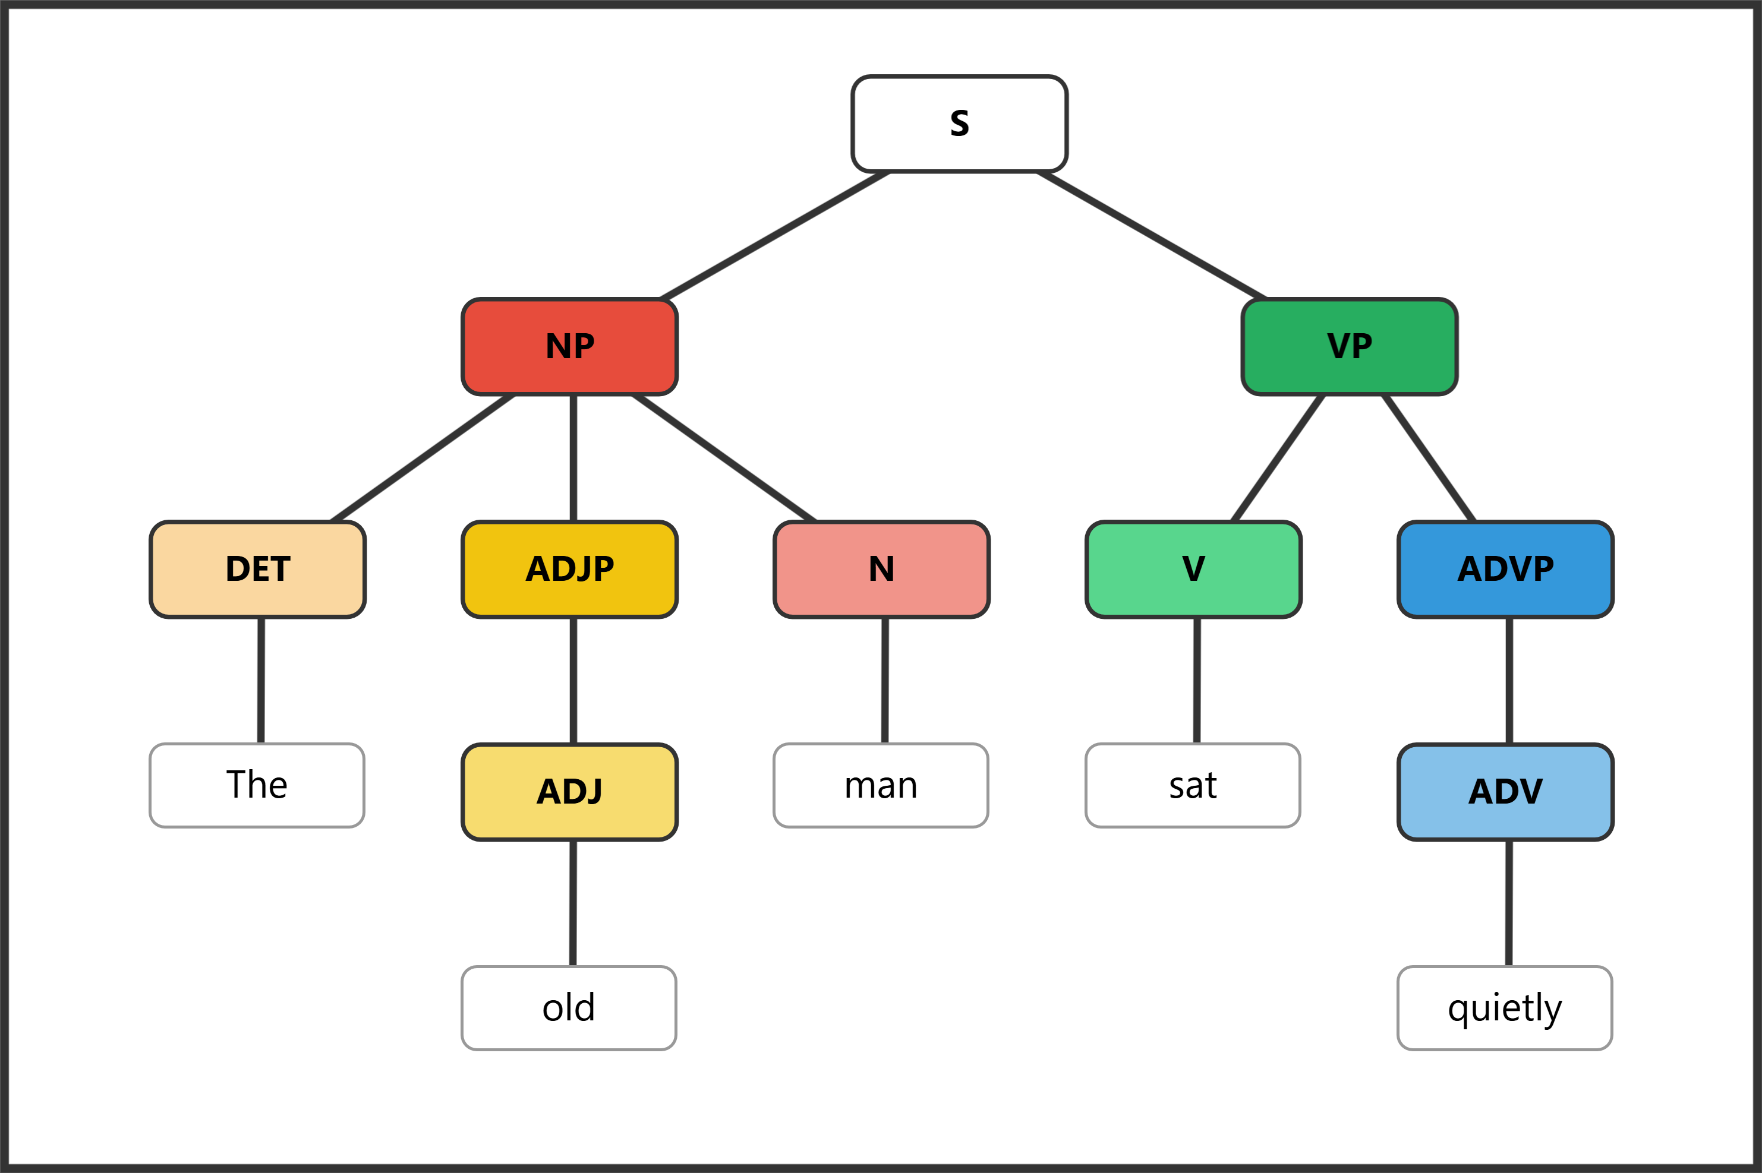

Question 14: The dog barked.
Role
Phrase
Word | The | dog | barked
POS
Bracket notation: ______________________________________________________________________

Question 15: The happy children played quietly in the park.
Role
Phrase
Word | The | happy | children | played | quietly | in | the | park
POS
Bracket notation: ______________________________________________________________________

Question 16: The teacher from Texas arrived early.
Role
Phrase
Word | The | teacher | from | Texas | arrived | early
POS
Bracket notation: ______________________________________________________________________

Question 17: Many talented musicians performed brilliantly during the annual festival.
Role
Phrase
Word | Many | talented | musicians | performed | brilliantly | during | the | annual | festival
POS
Bracket notation: ______________________________________________________________________

Question 18: The young artist with curly hair painted quite skillfully.
Role
Phrase
Word | The | young | artist | with | curly | hair | painted | quite | skillfully
POS
Bracket notation: ______________________________________________________________________

Bonus
Instructions: Write original sentences or phrases meeting each requirement below.
Bonus 1: Write a word that contains at least three morphemes. List each morpheme and label it as free or bound. (2 pts)
Word: ______________________________
Morphemes: ____________________________________________________________
Bonus 2: Write a noun phrase that contains a determiner, an adjective, and a noun. (2 pts)
___________________________________________________________________________
Bonus 3: Write a sentence containing a prepositional phrase that modifies a noun. Underline or circle the prepositional phrase. (2 pts)
___________________________________________________________________________

